Route Summary:

Ruckmarch: 15 Km

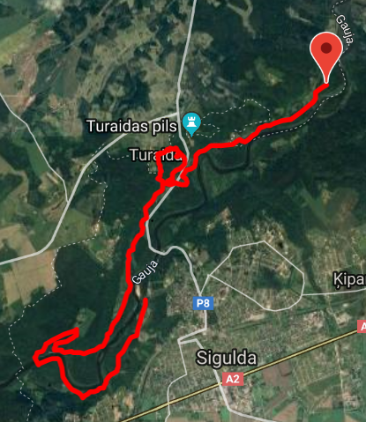

Portage: 1.5 Km

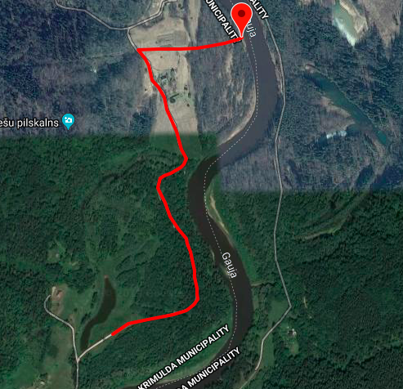

Canoe: 7.5 Km

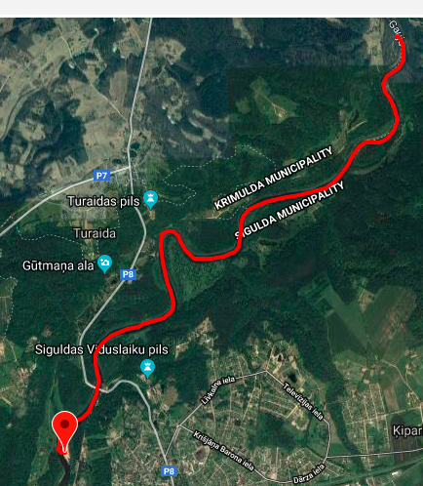

Ruckmarch: 4 Km

